Men’s Fertility
Men’s fertility acupuncture works in much the same way as it does for women. Research has shown that 40% of fertility cases are female factor, 40% male factor and 20% unknown. Chinese medicine has a long history of supporting male fertility, virility and longevity. Common issues such as low motility, morphology, and count, erectile dysfunction and low libido are direct markers of men’s future cardiovascular and overall health. By treating the root cause of the dysfunction the fertility issues resolve and overall health is restored. We use an integrative approach in treating male reproductive and sexual health. We recommend that all male partners be evaluated according to Chinese medicine.
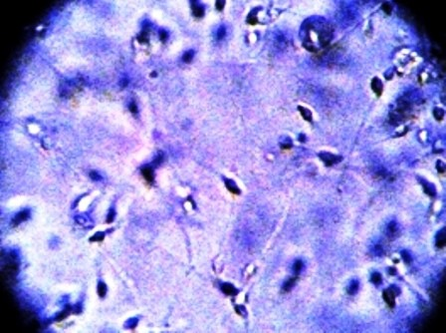
Men’s fertility acupuncture helps:
- improve sperm count
- improve sperm motility
- decrease in sperm DNA fragmentation
- resolve infection
- Increase libido
- increase semen quantity
- decrease mind and body stress
- address genetic factors
Acupuncture Treatment Recommendations
Men in general respond quickly to treatments with acupuncture. The quality and quality of sperm can be impacted more easily then the quality of eggs in women. This is because sperm are produced and mature much quicker than an egg matures in women. We suggest:
- Weekly acupuncture session for 3 months for most conditions.
- We recommend a minimum of 1 treatment around women’s ovulation for natural conception.
- We also recommend a minimum of one treatment within 24 hours of a sperm sample that will be given for IUI or IVF.
Acupuncture treatment around the time a sample is given has been shown produce better results than without acupuncture.
Diet and Lifestyle to Improve fertility
Because male fertility and sexual health is a marker of overall health our approach is holistic. We advise herbs and supplements in most cases. We will address common practices that reduce fertility like:
- Poor diet
- Cycling and over exercise
- Poor sleep and sleep hygiene
- Stress
- Overwork
- Hormonal imbalances

We will also refer on to an Andrologist if you need further assistance.
We will ask questions such as have you had mumps, an undescended testis, torsion of the testes or any injury to the testes. These can all impact your fertility, and if you don’t know, ask your mum prior to an appointment if there were any issues with your testes when you were little.
Lower back injuries can also affect men’s fertility. In my experience I have found that using body work such as massage, osteopathy, chiropractic and reflexology can also work hand in hand with our TCM treatments and assist with realigning the body back to its natural state of health.

